NAME:______________________________________________________ BLOCK:__________

THE COLD WAR

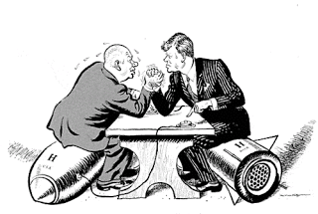
Directions: Complete the following pathway. You must complete the steps in order. After you complete each step, check in with me. You will have TWO CLASS PERIODS to complete this assignment. THIS PATHWAY IS WORTH 200 POINTS.

STEP ONE:

- Complete the Cold War Pre-Test.
- Finished? Self-check your answers (key located on the board)

Check In: ___________

1
STEP TWO:

- Complete The Cold War reading worksheet and questions.
- Self-check your answers with the key on the board.
Check In:__________

2

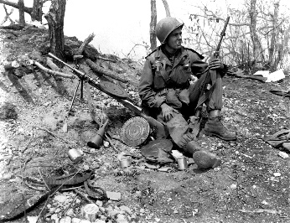
STEP THREE:

Complete the Cold War vocabulary sheet.

Check In:_________

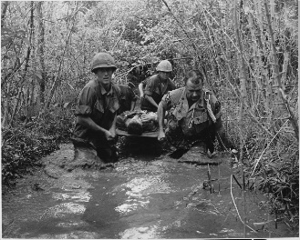
3

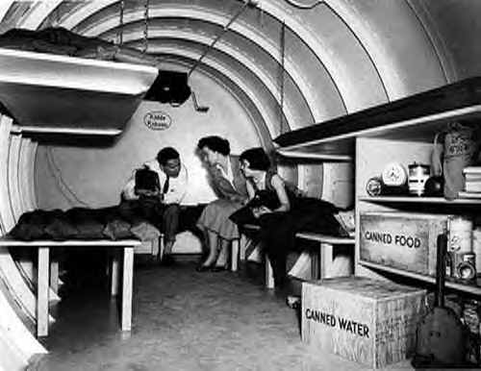
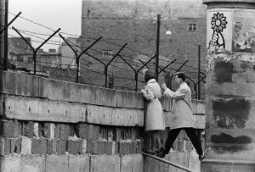
STEP FOUR:

- View the Cold War Prezi (link below) and complete the corresponding Notes.
http://prezi.com/i4iz1hx5rjom/?utm_campaign=share&utm_medium=copy&rc=ex0share

Check In:_____________

STEP FIVE:

- On BrainPop, view “Cold War” AND complete the Vocabulary Activity Worksheet.
[Login: palmbeach; Password: palmbeach]

Check In: ___________

5
4

