Name:_____________________________ Block:________

Industrial Revolution Inventions

Name of Invention | Inventor | Year Invented | Functions of Invention | Impact of Invention
The Power Loom
The Spinning Jenny
The Cotton Gin
The Steam Engine
The Locomotive
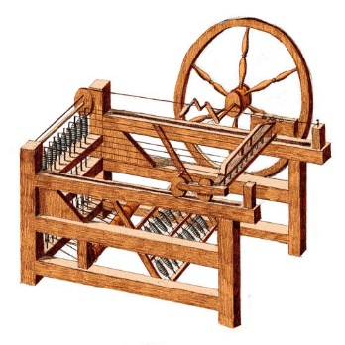
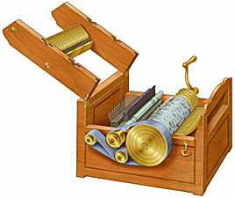

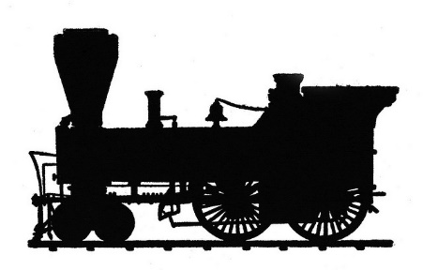

Name:_____________________________ Block:________

Industrial Revolution Inventions

Name of Invention | Inventor | Year Invented | Functions of Invention | Impact of Invention
The Power Loom
The Spinning Jenny
The Cotton Gin
The Steam Engine
The Locomotive
